Numerical Method

Name: Muhammad Izzudin Yusuf
NIM: 25/560389/TK/63290
Class: C - Teknik Biomedis

Nonlinear Equation:
Soft Tissue Exponential Deformation Equation

$σ=\frac{E_{0}}{a}(e^{aε}-1)$

$f(ε)=\frac{E_{0}}{a}(e^{aε} -1)-σ_{target}=0$

Keterangan variable:
- $ε$: Regangan aksial jaringan (strain)
- $σ$: Tegangan mekanis jaringan (stress, N/m²)
- $E_{0},a$: Konstanta material jaringan lunak yang ditentukan secara eksperimental (heart chordae tendineae)

Untuk mengevaluasi kedua konstanta material tersebut, persamaan di atas didiferensiasikan terhadap $ϵ$, yang merupakan hubungan fundamental untuk jaringan lunak

$\frac{dσ}{dε}=E_{0}+aσ$

Tabel ini berisi data tegangan-regangan untuk chordae tendineae jantung (tendon-tendon kecil yang berfungsi menahan katup jantung agar tetap tertutup selama kontraksi otot jantung). Data ini diperoleh saat jaringan diberi beban; kurva yang berbeda akan muncul saat beban dilepas.

Diferensial Model

$\frac{dσ}{dε}=E_{0}+aσ$

Pemetaan ke Persamaan Garis Lurus
$y=mx+c$
- Variabel independen ($x$): $σ$
- Variabel dependen ($y$): $\frac{dσ}{dε}$
- Slope ($m$): $a$
- Titik potong sumbu-$y$ ($c$): $E_{0}$
$σ (×{10}^{3} N/m^{2})$ | $ε (×{10}^{-3} m/m)$
87,8 | 153
96,6 | 198
176 | 270
263 | 320
350 | 355
569 | 410
833 | 460
1227 | 512
1623 | 562
2105 | 614
2677 | 664
3378 | 716
4257 | 766

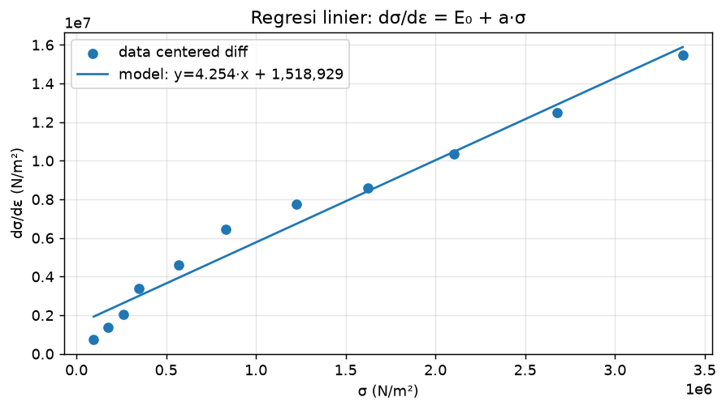
(Gambar diperbaiki: regresi linier dσ/dε = E₀ + a·σ.)
Penurunan Centered Finite Difference Method
- Taylor Series
$f(x)=\sum_{n=0}^{∞}{}\frac{f^{(n)}(a)}{n!}{ (x-a)}^{n}$$f(x)=f(a)+f'(a)(x-a)+\frac{f''(a)}{2!} {(x-a)}^{2}+ . . .$

Untuk mengaplikasikan Deret Taylor pada kurva hubungan tegangan $(σ)$ dan regangan $(ε)$, variabel $x$ digantikan oleh regangan $ε$, titik acuan $a$ digantikan oleh $ε_{i}$, dan selisih $(x-a)$ digantikan oleh jarak antar titik data $Δε$.
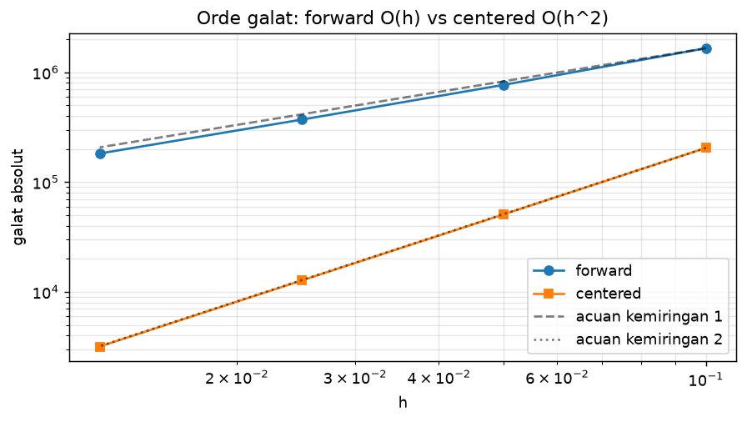
Pendekatan orde dua $O(Δε^{2})$ ini digunakan untuk meminimalkan galat pemotongan dibandingkan dengan backward/forward method. (penjelasan lebih lanjut terdapat pada repository github)
Bukti numerik (model eksponensial sebagai acuan eksak, titik i = 8): galat relatif forward 11,43%, backward 10,29%, centered 0,36% — forward ~30× lebih besar daripada centered.
Uji paruh-langkah di ε = 0,35: h = 0,050 → 0,025 mengecilkan galat forward ÷2 (7,69 → 3,71 ×10⁵, ciri O(h)) dan centered ÷4 (5,09 → 1,27 ×10⁴, ciri O(h²)).
h | forward | centered
0,1000 | 1,66e+06 | 2,05e+05
0,0500 | 7,69e+05 | 5,09e+04
0,0250 | 3,71e+05 | 1,27e+04
0,0125 | 1,82e+05 | 3,17e+03
- Ekspansi Deret (Forward and Backward)
- Forward Expansion:
$σ_{i+1}=σ_{i}+{(\frac{dσ}{dε})}_{i}Δε+\frac{1}{2}{(\frac{d^{2}σ}{dε^{2}})}_{i}Δε^{2}+ . . .pers. 1$
- Backward Expansion:
$σ_{i-1}=σ_{i}-{(\frac{dσ}{dε})}_{i}Δε+\frac{1}{2}{(\frac{d^{2}σ}{dε^{2}})}_{i}Δε^{2}- . . .pers. 2$
- Eliminasi Suku Berorde Genap
Operasi pengurangan $[Persamaan 1-Persamaan 2]$ untuk mengeliminasi suku-suku berorde genap ($σ_{i}$, turunan kedua $Δε^{2}$, dst.)
$σ_{i+1}-σ_{i-1}=[σ_{i}-σ_{i}]+[{(\frac{dσ}{dε})}_{i} Δε-(-{(\frac{dσ}{dε})}_{i} Δε)]+ . . .$
$σ_{i+1}-σ_{i-1}=2{(\frac{dσ}{dε})}_{i} Δε+\frac{1}{3}{(\frac{d^{3}σ}{dε^{3}})}_{i} Δε^{3}+ . . .$
- Formulasi Akhir
Dengan mengabaikan suku galat orde tinggi dan membagi kedua ruas dengan $2Δε=(ε_{i+1}-ε_{i-1})$ ,diperoleh rumus aproksimasi turunan:
$y_{i}={(\frac{dσ}{dε})}_{i}≈\frac{σ_{i+1}-σ_{i-1}}{ε_{i+1}-ε_{i-1}}$
Pemrosesan dan Diferensiasi Data
- Titik $i=2$
$y_{2}=\frac{(176-87,8)×{10}^{3}}{(270-153)×{10}^{-3}}=753.846 N/m^{2}$
- Titik $i=3$
$y_{3}=\frac{(263-96,6)×{10}^{3}}{(320-198)×{10}^{-3}}=1.363.934 N/m^{2}$
- Titik $i=4$
$y_{4}=\frac{(350-176)×{10}^{3}}{(355-270)×{10}^{-3}}=2.047.059 N/m^{2}$
Titik $(i)$ | $x_{i}=σ_{i} (N/m^{2})$ | $y_{i}={(\frac{dσ}{dε})}_{i} (N/m^{2})$
2 | 96.600 | 753.846
3 | 176.000 | 1.363.934
4 | 263.000 | 2.047.059
5 | 350.000 | 3.400.000
6 | 569.000 | 4.600.000
7 | 833.000 | 6.450.980
8 | 1.227.000 | 7.745.098
9 | 1.623.000 | 8.607.843
10 | 2.105.000 | 10.333.333
11 | 2.677.000 | 12.480.392
12 | 3.378.000 | 15.490.196

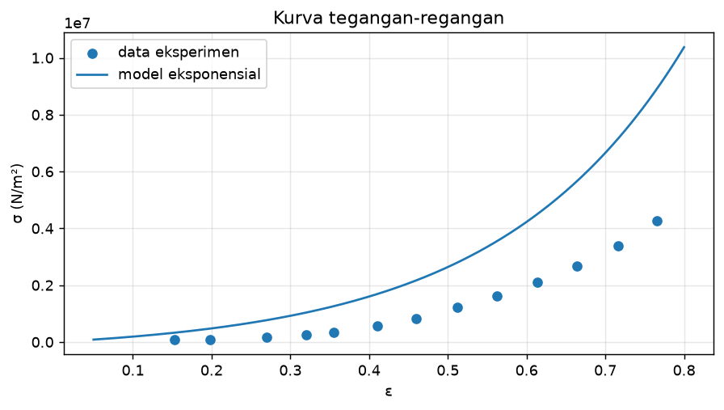
Catatan:
Titik $i=1 (σ_{1}=87.800)$ dan titik $i=13 (σ_{13}=4.257.000)$ merupakan titik batas (boundary points), sehingga tidak memiliki pasangan nilai $y_{i}$ pada metode beda hingga terpusat karena memerlukan data tetangga di luar rentang tabel. Total data internal yang digunakan dalam analisis regresi linier adalah $n=11$ titik.

Analisis Regresi Kuadrat Terkecil (Least-Squares Regression)

$a=\frac{nΣ(x_{i}y_{i})-Σx_{i}Σy_{i}}{nΣx_{i}^{2}-{(Σx_{i})}^{2}}≈4,253735$ dan $E_{0}=\underline{y}-a\underline{x}≈1.518.928,89$ N/m²
Hasil regresi: a = 4,253735, E₀ = 1.518.928,89 N/m², R² = 0,971782 — identik melalui perhitungan manual, scipy.stats.linregress, dan numpy.polyfit.

Analisis Penentuan $σ_{target}$ untuk Pencarian Akar
Nilai $σ_{target}$ dicari menggunakan Analisis Multi-Kriteria Terbobot (Weighted Multi-Criteria Analysis) dengan metode-metode yang digunakan berupa (a) Invers Model, (b) Centered Finite Difference (Numerical Derivative Check), (c) Sign-Change Root Detection, (d) Weighted Scoring (5 Kriteria: validitas braket, sentralitas skar, kondisi turunan, konsistensi turunan, dan kedekatan invers).
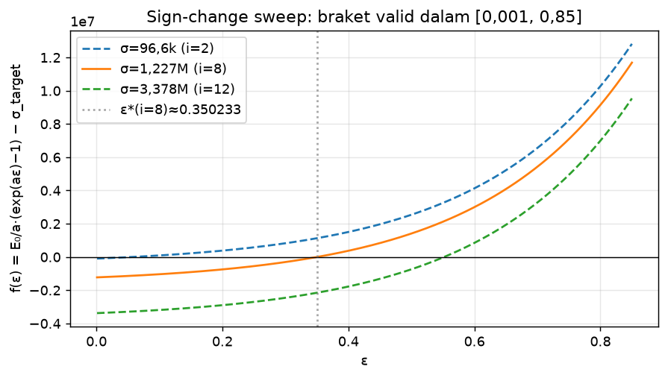
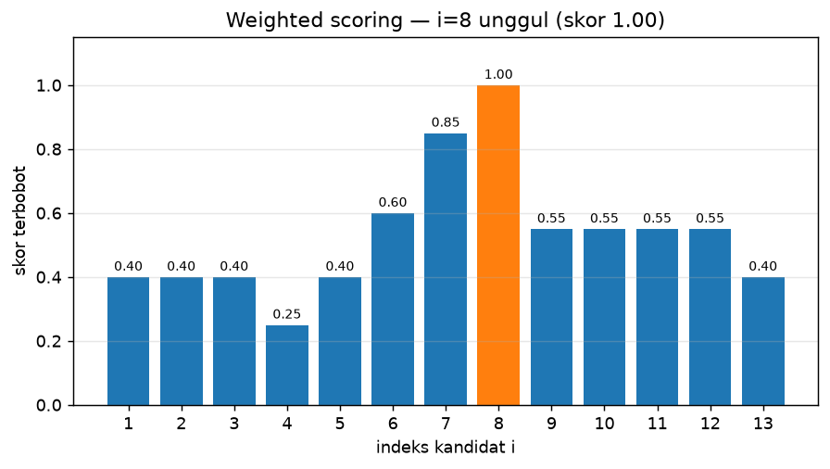
$σ_{target}=1.227.000$ N/m²
Tabel skor terbobot 5 kriteria (K1 25%, K2 20%, K3 25%, K4 15%, K5 15%). Baris pemenang ditandai.
Pemenang: i = 8, σ = 1.227.000 N/m², ε_exact ≈ 0,350233, skor terbobot 1,00 (5/5).
i | σ | ε_exact | f' | K1 | K2 | K3 | K4 | K5 | Biner | Terbobot
1 | 87800 | 0,051683 | 1,892407e+06 | 1 | 0 | 0 | 0 | 1 | 2 | 0,40
2 | 96600 | 0,056287 | 1,929840e+06 | 1 | 0 | 0 | 0 | 1 | 2 | 0,40
3 | 176000 | 0,094202 | 2,267586e+06 | 1 | 0 | 0 | 0 | 1 | 2 | 0,40
4 | 263000 | 0,129742 | 2,637661e+06 | 1 | 0 | 0 | 0 | 0 | 1 | 0,25
5 | 350000 | 0,160608 | 3,007736e+06 | 1 | 0 | 0 | 1 | 0 | 2 | 0,40
6 | 569000 | 0,224038 | 3,939304e+06 | 1 | 1 | 0 | 1 | 0 | 3 | 0,60
7 | 833000 | 0,283002 | 5,062290e+06 | 1 | 1 | 1 | 0 | 1 | 4 | 0,85
8 | 1227000 | 0,350233 | 6,738262e+06 | 1 | 1 | 1 | 1 | 1 | 5 | 1,00
9 | 1623000 | 0,402688 | 8,422741e+06 | 1 | 0 | 0 | 1 | 1 | 3 | 0,55
10 | 2105000 | 0,453907 | 1,047304e+07 | 1 | 0 | 0 | 1 | 1 | 3 | 0,55
11 | 2677000 | 0,503017 | 1,290618e+07 | 1 | 0 | 0 | 1 | 1 | 3 | 0,55
12 | 3378000 | 0,551882 | 1,588805e+07 | 1 | 0 | 0 | 1 | 1 | 3 | 0,55
13 | 4257000 | 0,601567 | 1,962708e+07 | 1 | 0 | 0 | 0 | 1 | 2 | 0,40

Sehingga persamaan non-linear utama yang akan dievaluasi pada open methods dan bracketing methods:
- Bentuk Umum:
$f(ε)=\frac{E_{0}}{a}(e^{aε} -1)-σ_{target}=0$
- Substitusi Nilai Parameter:
$f(ε)=\frac{1.518.928,89}{4,253735}(e^{4,253735ε} -1)-1.227.000=0$
- Solusi Eksak (Analisis)
$ε_{exact}=\frac{1}{4,253735}ln(\frac{4,253735×1.227.000}{1.518.928,89}+1)≈0,350233$

Formulasi Turunan Fungsi
- Turunan pertama $f'(ε):$
$f'(ε)=E_{0}e^{aε}≈1.518.928,89 e^{4,253735ε}$ N/m²
- Turunan kedua $f''(ε):$
$f''(ε)=aE_{0}e^{aε}≈6.461.121 e^{4,253735ε}$ N/m²

Kriteria Penghentian Perulangan (Stopping Criterion)
Proses iterasi pada seluruh open methods dan bracketing methods akan dihentikan apabila nilai galat relatif telah memenuhi batas toleransi $E_{a}=1,0×{10}^{-5} (ε_{a}<E_{a})$ atau jumlah perulangan telah mencapai batas maksimum ($maxit=30$).

Sumber: Chapra, S. C., & Canale, R. P. (2015). Numerical Methods for Engineers (7th ed., hlm. 684, Problem 24.9). McGraw-Hill Education.

- Open Methods
- The Simple Fixed-Point Iteration
Solution:
Persamaan $f(ε)=0$ diubah ke bentuk $ε=g(ε)$ dengan skema:
$ε_{n+1}=g(ε_{n})=ε_{n}-αf(ε_{n}), α=\frac{1}{f'(ε_{mid})}$
$ε_{mid}=0.35$ m/m (titik tengah braket) digunakan agar syarat konvergensi $|g'(ε)|<1$ terpenuhi.
Code:
def fixed_point(eps0=0.01, tol=TOL, max_iter=MAX_IT):
"""
Fixed-Point Iteration: eps_{n+1} = g(eps_n)
Relaksasi: g(eps) = eps - alpha*f(eps), alpha = 1/f'(eps_mid),
eps_mid = titik tengah braket [0,1; 0,6] agar |g'(eps)| < 1.
"""
# Gunakan alpha dari titik mendekati solusi agar konvergen
# alpha = 1/f'(eps_mid) dengan eps_mid = nilai tengah braket
eps_mid = (0.1 + 0.6) / 2
alpha = 1.0 / fp(eps_mid)

eps = eps0
hist = [eps]
errors = []
err = float('inf')
for i in range(max_iter):
eps_new = eps - alpha * f(eps)
# clamp agar tidak keluar rentang fisik
eps_new = max(0.001, min(0.85, eps_new))
err = abs(eps_new - eps)
errors.append(err)
hist.append(eps_new)
eps = eps_new
if err < tol:
break
return {'root': eps, 'iterations': i+1, 'history': hist,
'errors': errors, 'converged': err < tol}

res_fpi = fixed_point()
print("Fixed-Point Iteration")
print(f" Akar: eps = {res_fpi['root']:.10f} m/m")
print(f" f(eps) = {f(res_fpi['root']):.4e}")
print(f" Iterasi: {res_fpi['iterations']} | Error: {res_fpi['errors'][-1]:.4e}")
print(f" Konvergen: {res_fpi['converged']}")

Output:
- Akar: eps = 0.3502325848 m/m
- f(eps) = -1.6905e-04
- Iterasi: 6 | Error: 2.5369e-08

- The Newton-Raphson Method
Solution:
$ε_{n+1}=ε_{n}-\frac{f(ε_{n})}{f'(ε_{n})} , f'(ε)=E_{0}e^{aε}$
Code:
def newton_raphson(eps0=0.01, tol=TOL, max_iter=MAX_IT):
eps = eps0
hist = [eps]
errors = []
err = float('inf')
for i in range(max_iter):
fv = f(eps)
fpv = fp(eps)
if abs(fpv) < 1e-30:
break
eps_new = eps - fv / fpv
err = abs(eps_new - eps)
errors.append(err)
hist.append(eps_new)
eps = eps_new
if err < tol:
break
return {'root': eps, 'iterations': i+1, 'history': hist,
'errors': errors, 'converged': err < tol}

res_nr = newton_raphson()
print("Newton-Raphson Method")
print(f" Akar: eps = {res_nr['root']:.10f} m/m")
print(f" f(eps) = {f(res_nr['root']):.4e}")
print(f" Iterasi: {res_nr['iterations']} | Error: {res_nr['errors'][-1]:.4e}")

Output:
- Akar: eps = 0.3502325848 m/m
- f(eps) = 8.5635e-07
- Iterasi: 7 | Error: 2.4447e-07

  - Modified Newton-Raphson Method for Multiple Roots
Solution:
$ε_{n+1}=ε_{n}-\frac{f(ε_{n})f'(ε_{n})}{{[f'(ε_{n})]}^{2}-f(ε_{n})f''(ε_{n})}$
Code:
def modified_newton_raphson(eps0=0.01, tol=TOL, max_iter=MAX_IT):
eps = eps0
hist = [eps]
errors = []
err = float('inf')
for i in range(max_iter):
fv = f(eps)
fpv = fp(eps)
fppv = fpp(eps)
denom = fpv**2 - fv * fppv
if abs(denom) < 1e-30:
break
eps_new = eps - (fv * fpv) / denom
err = abs(eps_new - eps)
errors.append(err)
hist.append(eps_new)
eps = eps_new
if err < tol:
break
return {'root': eps, 'iterations': i+1, 'history': hist,
'errors': errors, 'converged': err < tol}

res_mnr = modified_newton_raphson()
print("Modified Newton-Raphson")
print(f" Akar: eps = {res_mnr['root']:.10f} m/m")
print(f" f(eps) = {f(res_mnr['root']):.4e}")
print(f" Iterasi: {res_mnr['iterations']} | Error: {res_mnr['errors'][-1]:.4e}")

def modified_newton_raphson(eps0=0.01, tol=TOL, max_iter=MAX_IT):
eps = eps0
hist = [eps]
errors = []
err = float('inf')
for i in range(max_iter):
fv = f(eps)
fpv = fp(eps)
fppv = fpp(eps)
denom = fpv**2 - fv * fppv
if abs(denom) < 1e-30:
break
eps_new = eps - (fv * fpv) / denom
err = abs(eps_new - eps)
errors.append(err)
hist.append(eps_new)
eps = eps_new
if err < tol:
break
return {'root': eps, 'iterations': i+1, 'history': hist,
'errors': errors, 'converged': err < tol}

res_mnr = modified_newton_raphson()
print("Modified Newton-Raphson")
print(f" Akar: eps = {res_mnr['root']:.10f} m/m")
print(f" f(eps) = {f(res_mnr['root']):.4e}")
print(f" Iterasi: {res_mnr['iterations']} | Error: {res_mnr['errors'][-1]:.4e}")

Output:
- Akar: eps = 0.3502325848 m/m
- f(eps) = -2.3283e-10
- Iterasi: 6 | Error: 2.1999e-09

- The Secant Method
Solution:
$ε_{i+1}=ε_{i}-\frac{f(ε_{i})(ε_{i-1}-ε_{i})}{f(ε_{i-1})-f(ε_{i})}$
Code:
def secant(eps0=0.01, eps1=0.05, tol=TOL, max_iter=MAX_IT):
hist = [eps0, eps1]
errors = []
err = float('inf')
for i in range(max_iter):
f0 = f(eps0); f1 = f(eps1)
if abs(f1 - f0) < 1e-30:
break
eps_new = eps1 - f1 * (eps0 - eps1) / (f0 - f1)
err = abs(eps_new - eps1)
errors.append(err)
hist.append(eps_new)
eps0, eps1 = eps1, eps_new
if err < tol:
break
return {'root': eps1, 'iterations': i+1, 'history': hist,
'errors': errors, 'converged': err < tol}

res_sec = secant()
print("Secant Method")
print(f" Akar: eps = {res_sec['root']:.10f} m/m")
print(f" f(eps) = {f(res_sec['root']):.4e}")
print(f" Iterasi: {res_sec['iterations']} | Error: {res_sec['errors'][-1]:.4e}")

Output:
- Akar: eps = 0.3502325848 m/m
- f(eps) = -2.4375e-04
- Iterasi: 9 | Error: 2.6401e-07
  - Modified Secant Method
Solution:
$ε_{n+1}=ε_{n}-\frac{δε_{n} . f(ε_{n})}{f(ε_{n}+δε_{n})-f(ε_{n})}$
Code:
def modified_secant(eps0=0.01, delta=0.01, tol=TOL, max_iter=MAX_IT):
eps = eps0
hist = [eps]
errors = []
err = float('inf')
for i in range(max_iter):
fv = f(eps)
f_pert = f(eps + delta * eps)
denom = f_pert - fv
if abs(denom) < 1e-30:
break
eps_new = eps - (delta * eps * fv) / denom
err = abs(eps_new - eps)
errors.append(err)
hist.append(eps_new)
eps = eps_new
if err < tol:
break
return {'root': eps, 'iterations': i+1, 'history': hist,
'errors': errors, 'converged': err < tol}

res_msec = modified_secant()
print("Modified Secant Method")
print(f" Akar: eps = {res_msec['root']:.10f} m/m")
print(f" f(eps) = {f(res_msec['root']):.4e}")
print(f" Iterasi: {res_msec['iterations']} | Error: {res_msec['errors'][-1]:.4e}")

Output:
- Akar: eps = 0.3502326199 m/m
- f(eps) = 2.3641e-01
- Iterasi: 7 | Error: 4.6803e-06

- Brent’s Method
Solution:
Menggabungkan Bisection + Secant + Inverse Quadratic Interpolation. Selalu
konvergen (seperti bisection) sekaligus cepat (seperti IQI/secant)

Code:
def brents_method(a_b=0.1, b_b=0.6, tol=TOL, max_iter=MAX_IT):
fa, fb = f(a_b), f(b_b)
if fa * fb > 0:
raise ValueError("f(a) dan f(b) harus berlawanan tanda.")
if abs(fa) < abs(fb):
a_b, b_b = b_b, a_b
fa, fb = fb, fa
c, fc = a_b, fa
mflag = True
s = d = 0.0
hist = [b_b]
errors = []
err = float('inf')
for i in range(max_iter):
if fa != fc and fb != fc:
s = (a_b*fb*fc/((fa-fb)*(fa-fc)) +
b_b*fa*fc/((fb-fa)*(fb-fc)) +
c *fa*fb/((fc-fa)*(fc-fb)))
else:
s = b_b - fb*(b_b-a_b)/(fb-fa)
c1 = not ((3*a_b+b_b)/4 < s < b_b or b_b < s < (3*a_b+b_b)/4)
c2 = mflag and abs(s-b_b) >= abs(b_b-c)/2
c3 = not mflag and abs(s-b_b) >= abs(c-d)/2
c4 = mflag and abs(b_b-c) < tol
c5 = not mflag and abs(c-d) < tol
if c1 or c2 or c3 or c4 or c5:
s = (a_b + b_b) / 2
mflag = True
else:
mflag = False
fs = f(s); d = c; c = b_b; fc = fb
if fa * fs < 0:
b_b = s; fb = fs
else:
a_b = s; fa = fs
if abs(fa) < abs(fb):
a_b, b_b = b_b, a_b
fa, fb = fb, fa
err = abs(b_b - a_b)
errors.append(err)
hist.append(b_b)
if err < tol or abs(fb) < 1e-14:
break
return {'root': b_b, 'iterations': i+1, 'history': hist,
'errors': errors, 'converged': err < tol}

res_brent = brents_method()
print("Brent's Method")
print(f" Akar: eps = {res_brent['root']:.10f} m/m")
print(f" f(eps) = {f(res_brent['root']):.4e}")
print(f" Iterasi: {res_brent['iterations']} | Error: {res_brent['errors'][-1]:.4e}")

Output:
- Akar: eps = 0.3502325706 m/m
- f(eps) = -9.5410e-02
- Iterasi: 6 | Error: 5.0017e-06

- Braketing Methods/Closed Methods
- Graphical Approach
Solution:
Menggunakan pendekatan grafik
Code:
eps_g = np.linspace(0.001, 0.75, 800)
f_g = f(eps_g)

fig, ax = plt.subplots(figsize=(9, 4.5))
ax.plot(eps_g, f_g/1e6, 'steelblue', lw=2.2)
ax.axhline(0, color='k', lw=1.2, ls='--')
ax.axvline(eps_star, color='crimson', lw=2, ls=':',
label=f'Akar eps* ~ {eps_star:.5f} m/m')
ax.fill_between(eps_g, f_g/1e6, 0, where=(f_g<0), alpha=0.12, color='blue', label='f < 0')
ax.fill_between(eps_g, f_g/1e6, 0, where=(f_g>0), alpha=0.12, color='red', label='f > 0')
ax.plot(eps_star, 0, 'o', color='crimson', ms=10, zorder=5)
ax.annotate(f' eps* ~ {eps_star:.4f}',
xy=(eps_star, 0), fontsize=10, color='crimson', xytext=(eps_star+0.03, 0.8))
ax.set_xlabel('Regangan eps (m/m)', fontsize=11)
ax.set_ylabel('f(eps) [x1e6 N/m2]', fontsize=11)
ax.set_title('Graphical Approach', fontsize=12)
ax.legend(fontsize=9); ax.grid(True, alpha=0.3)
plt.tight_layout()
plt.savefig('graphical.png', dpi=130, bbox_inches='tight')
plt.show()
print(f"Akar terbaca grafis: eps* ~ {eps_star:.4f} m/m")

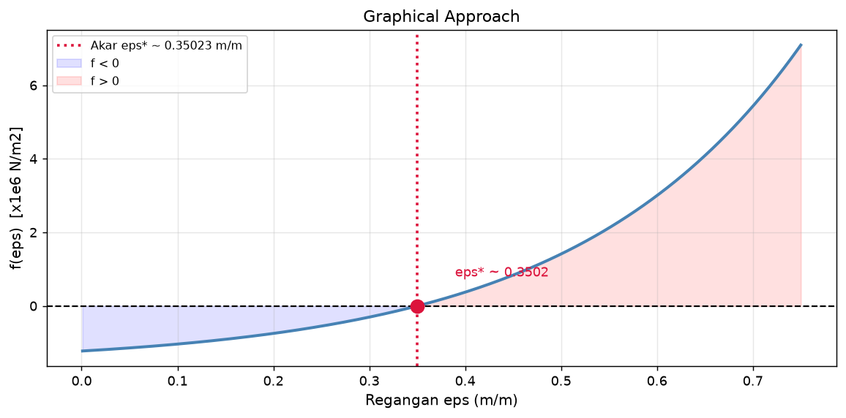
Akar terbaca grafis: eps* ~ 0.3502 m/m

- The Bisection Method
Solution:
$ε_{mid}=\frac{ε_{lo}+ε_{hi}}{2}$
Code:
def bisection(lo=0.1, hi=0.6, tol=TOL, max_iter=MAX_IT):
flo = f(lo)
hist = []
errors = []
err = float('inf')
for i in range(max_iter):
mid = (lo + hi) / 2.0
fmid = f(mid)
err = abs(hi - lo) / 2.0
hist.append(mid)
errors.append(err)
if flo * fmid < 0:
hi = mid
else:
lo = mid; flo = fmid
if err < tol:
break
return {'root': mid, 'iterations': i+1, 'history': hist,
'errors': errors, 'converged': err < tol}

res_bis = bisection()
print("Bisection Method")
print(f" Akar: eps = {res_bis['root']:.10f} m/m")
print(f" f(eps) = {f(res_bis['root']):.4e}")
print(f" Iterasi: {res_bis['iterations']} | Error: {res_bis['errors'][-1]:.4e}")

Output:
- Akar: eps = 0.3502365112 m/m
- f(eps) = 2.6458e+01
- Iterasi: 16 | Error: 7.6294e-06

- The False-Position Method
Solution:
$ε_{r}=ε_{hi}-\frac{f{(ε}_{hi})(ε_{lo}-ε_{hi})}{f(ε_{lo})-f(ε_{hi})}$
Code:
def false_position(lo=0.1, hi=0.6, tol=TOL, max_iter=MAX_IT):
flo = f(lo); fhi = f(hi)
eps_r_old = lo
hist = []
errors = []
err = float('inf')
for i in range(max_iter):
eps_r = hi - fhi * (lo - hi) / (flo - fhi)
fr = f(eps_r)
err = abs(eps_r - eps_r_old)
hist.append(eps_r)
errors.append(err)
if flo * fr < 0:
hi = eps_r; fhi = fr
else:
lo = eps_r; flo = fr
eps_r_old = eps_r
if i > 0 and err < tol:
break
return {'root': eps_r, 'iterations': i+1, 'history': hist,
'errors': errors, 'converged': err < tol}

res_fp = false_position()
print("False-Position Method")
print(f" Akar: eps = {res_fp['root']:.10f} m/m")
print(f" f(eps) = {f(res_fp['root']):.4e}")
print(f" Iterasi: {res_fp['iterations']} | Error: {res_fp['errors'][-1]:.4e}")

Output:
- Akar: eps = 0.3502257087 m/m
- f(eps) = -4.6332e+01
- Iterasi: 13 | Error: 8.7911e-06

Visualisasi Perbandingan Konvergensi
Tabel perbandingan semua metode (solusi analitik acuan: ε* = 0,3502325848 m/m).
Metode | Kategori | Tebakan / Braket | Akar ε* | f(ε*) | Iterasi | Error | Konvergen
Graphical | Bracketing | [0,1, 0,6] | 0,350233 | 0 | - | (visual) | Ya
Fixed-Point Iter. | Open | ε0 = 0,01 | 0,3502325848 | -0,000169 | 6 | 2,537e-08 | Ya
Newton-Raphson | Open | ε0 = 0,01 | 0,3502325848 | 8,564e-07 | 7 | 2,445e-07 | Ya
Modified NR (Halley) | Open | ε0 = 0,01 | 0,3502325848 | -2,328e-10 | 6 | 2,200e-09 | Ya
Secant | Open | ε0=0,01, ε1=0,05 | 0,3502325848 | -0,0002438 | 9 | 2,640e-07 | Ya
Modified Secant | Open | ε0=0,01, d=0,01 | 0,3502326199 | 0,2364 | 7 | 4,680e-06 | Ya
Brent's | Open+Bracket | [0,1, 0,6] | 0,3502325706 | -0,09541 | 6 | 5,002e-06 | Ya
Bisection | Bracketing | [0,1, 0,6] | 0,3502365112 | 26,46 | 16 | 7,629e-06 | Ya
False-Position | Bracketing | [0,1, 0,6] | 0,3502257087 | -46,33 | 13 | 8,791e-06 | Ya
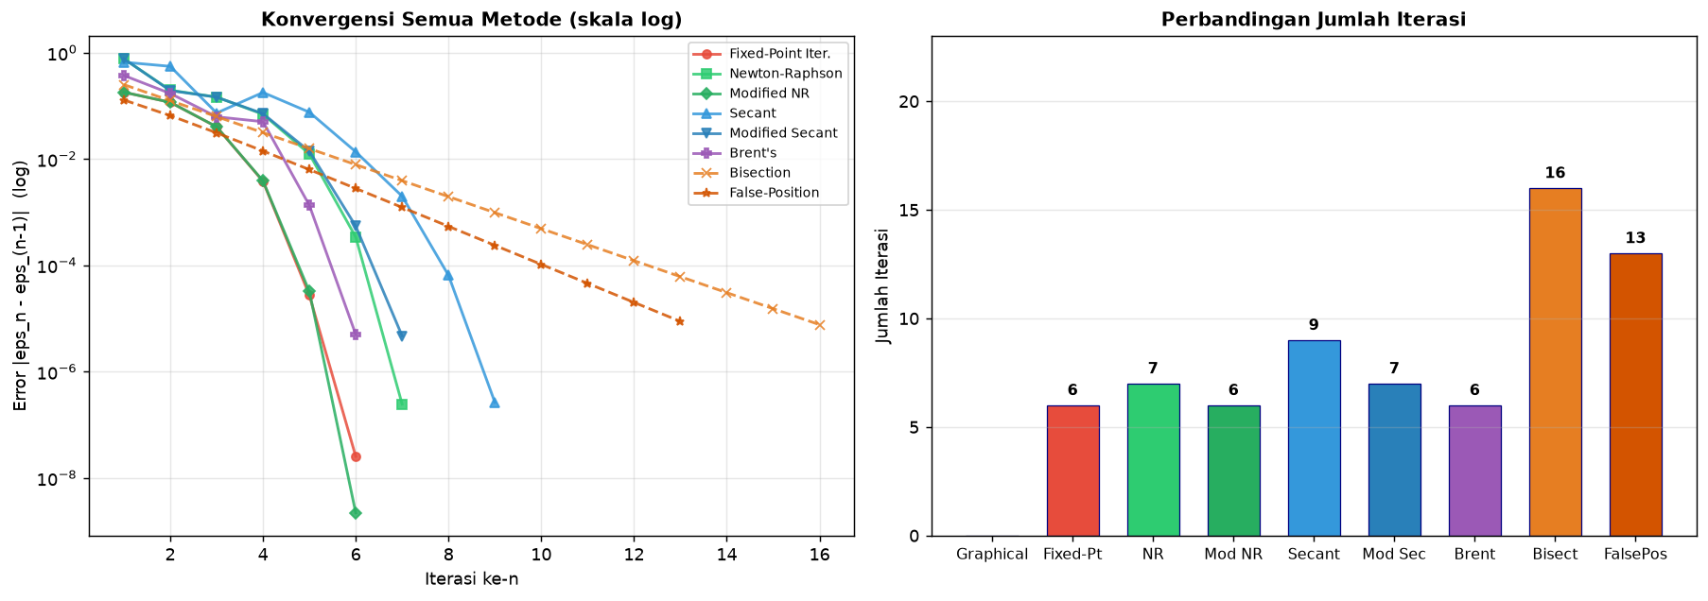
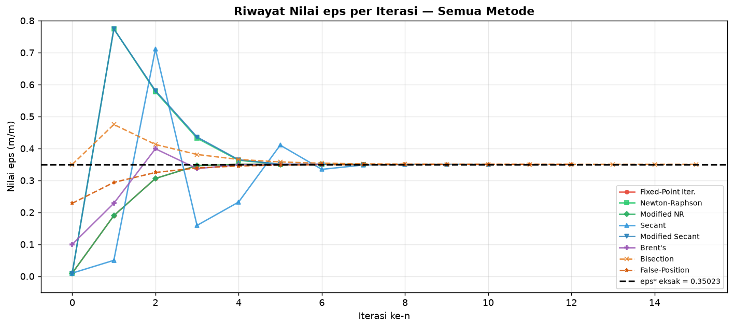
Kesimpulan
Hasil inti. Persamaan deformasi eksponensial jaringan lunak diselesaikan untuk σ_target = 1.227.000 N/m² (regangan acuan ε* ≈ 0,350233). Seluruh metode terbuka (fixed-point, Newton-Raphson, Halley, secant, mod-secant) dan metode tertutup/hibrida (graphical, bisection, false-position, Brent) konvergen ke akar yang sama dengan kriteria Ea < 10⁻⁵ dan maksimum 50 iterasi.
Perbandingan. Metode terbuka tercepat (6–9 iterasi; tercepat fixed-point dan Halley 6 iterasi) namun bergantung pada tebakan awal ε₀ = 0,01; metode tertutup pada braket [0,1, 0,6] selalu konvergen dengan harga iterasi lebih mahal (biseksi 16, false-position 13), sedangkan Brent (6 iterasi) menggabungkan keunggulan keduanya. Jadi, untuk persamaan ini, metode terbuka layak dipakai bila tebakan awal baik, dan Brent menjadi pilihan paling seimbang antara kecepatan dan jaminan konvergensi.

Source code: https://github.com/HyoSeop1488/Numerical-Method-1.git

